Quality Waterjet Newsletter – 11/14/2006  AWJ Cutting of Glass Fibre Reinforced Composites  – Delamination Issue  Anyone who has experiences in cutting composites with abrasive waterjets (AWJ) knows that delamination is the main issue in productivity and quality. Karpiński & Wantuch* conducted a study to provide insight and solution to this issue. Here are the highlights.  The causes of delamination were linked to two sources. One of them is the material itself. The material may contain flaws like non-uniform fibrous distribution, damaged fabric in weaving stage, non-uniform resin saturation, and porosity. The other source has to do with the AWJ cutting process. When the maximum cutting depth is reached, the jet is deflected the most and the pressure on the bottom layers may exceed composite adhesion force – causing delamination. Earlier works of others suggested that instability of abrasive flow is largely responsible for delamination of composite in AWJ cutting. An experiment was done by the authors to provide an insight of what is actually happening. A fast camera (250 frames/sec) was used to monitor the abrasive flow through a glass tube inserted into the abrasive feed line. The length of the abrasive lines was 6 meters (based on a commercial waterjet machine) in one test and 2 meters in another for comparison. It was found that, for the 6 m long abrasive line, the particle density, passing the same spot of the glass tube, varied between 22 to 96% within the time frame of 0.016-0.024 sec, a clear indication of instability of abrasive flow. This was believed to lead to a short-duration higher pressure at the bottom layers, causing delamination.  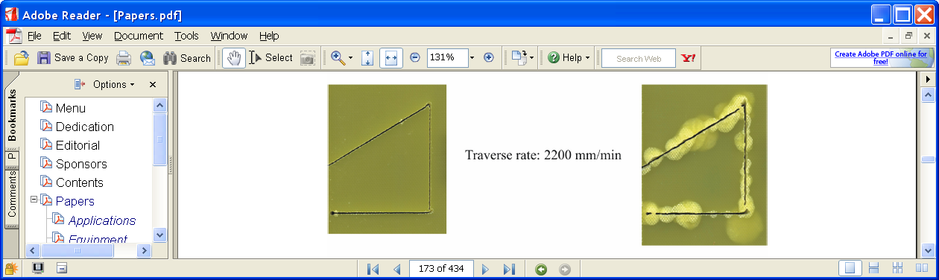  By reducing the length of the feed line to 2 meters, the instability situation was improved. Further comparative cutting tests were done with 0.2 m and 2 m long feed lines on 10 mm thick glass/epoxy composites. The photos show the results (0.2 m left; 2 m right) at the cutting speed of 2200 mm/min. Because of enhanced abrasive flow stability, the short feed line increases the cutting speeds about 60% without causing delamination.  To minimize the damage caused by delamination, the idea of real-time monitoring delamination with acoustic emission (AE) sensor was tested. It was found that the AE signal gives a reliable indication of even small delamination (see photos).  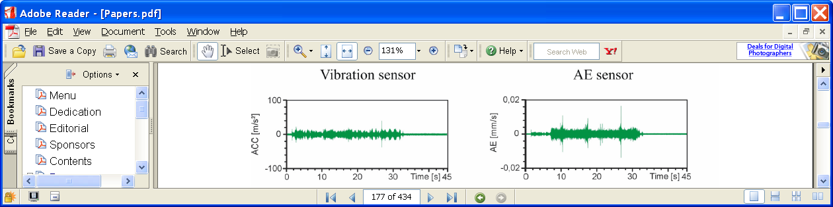  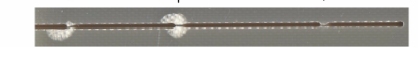  * Karpiński A. & Wantuch, E. (2006) The delamination problem of the glass fibre reinforced composites during the abrasive water jet cutting, in Peter Longman (Ed.), Proceedings of the 18th International Conference on Water Jetting, Gdansk, Poland, September 2006, pp 167-179. |  | QualJet LLC  Quality Waterjet  Spare Parts Specialist  - Quality Waterjet Spare Parts  - Meets/exceeds OEM standards  - 30% longer operation life time than competing products  - Extensive Parts Coverage for:  - Flow style, IR Style  - 40K/55K pumps  - Intensifiers  - On/off valves  - Cutting head  - Swivels  - OEM Expert  - 20+ year waterjet OEM experience (via OH Precision)  - Accept small OEM order  Durable, Compact 40K PSI Pumps  - Long operation lifetime  - Highly cost-effective  - Light weight and compact  - Contact us for  - Custom power end  - 50K psi models  - Private labeling  - Custom design  QualJet LLC  12819 SE 38th Street, #240  Bellevue, WA 98006  1-866-QUALJET (782-5538)  Fax: 425-378-7776  Email: info@qualjet.com  Website: www.qualjet.com  To unsubscribe the newsletter: unsubscribe@qualjet.com  For newsletter archive:  www.qualjet.com/Newsletter.htm  Copyright ©2005, QualJet LLC

